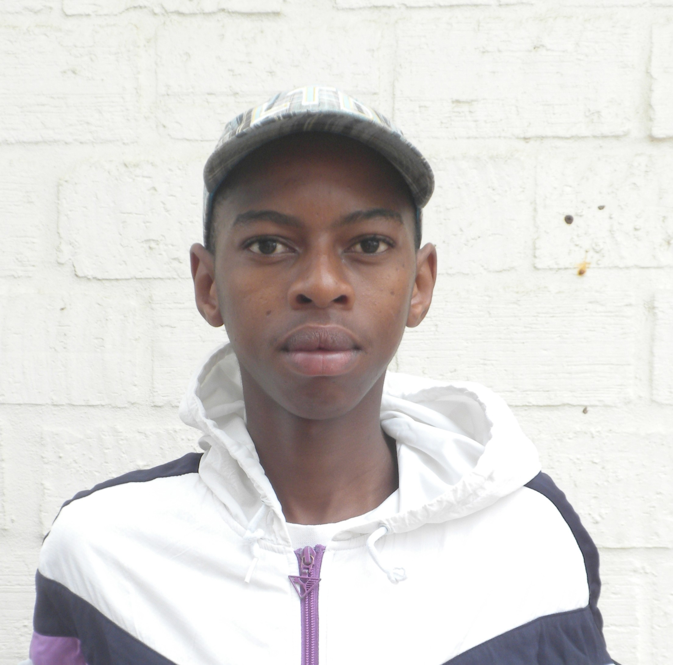Clean and Returning to School
Story of Champions League Player Yolani Benge
Khayelitsha, South Africa

“I want to stay clean for my dad. He has always supported me and I
want to make him proud.”

Yolani Benge, age 18, states as a large smile spreads across his face when he is told that he has passed his Champions League drug and alcohol test for the third straight week.

Yolani is not only the youngest member of his team, but of the entire Champion’s League programme. He dropped out of Metric, one year before graduating in 2011. When asked why he dropped out, with a deep sense of self-­‐understanding and reluctance, Yolani responds, “No good reason or excuse, I started smoking and dropped out.”

Back in April when Yolani first entered the Champions League programme, he was withdrawn and isolated. Often found alone, Yolani was always the first to leave when the last whistle was blown, seeking as little interaction as possible with his teammates and coaches. Yolani admits that due to substance abuse, when he started Champion’s League he was never fully present – physically or mentally.

In May, before finding out his most recent drug and alcohol results, Yolani reached out for help to stay clean. Champions League and Grassroot Soccer connected Yolani to Matrix, a substance abuse agency in the Town 2 of Khayelitsha. Matrix screened, assessed, and placed Yolani into a 16-­‐week programme, which provides him with group counseling and individual check ins.

Since joining Matrix, Yolani has passed every drug and alcohol test, and has experienced a dramatic change in personality, becoming one of the most active participants in Champion’s League. Yolani can usually be found hanging out at the Football for Hope Centre, trying to convince other players to take advantage of the resources offered by Champions League. He even assisted in the planning of a Grassroot Soccer HCT (HIV Counseling and Testing) Soccer Tournament.

On a rainy Monday morning in June, Yolani did not show up to the Football for Hope Centre for transport to his Matrix counseling session or for practice that evening. Both were quite uncommon, since until then he had had perfect attendance, attending every Champions League practice and match.

Visibly nervous, Yolani showed up the following Thursday at the centre for transport to his Matrix appointment. Overly apologetic for missing practice and his counseling session, Yolani explained how on Monday his grandmother had taken him clothes shopping, as a sign of her pride in him being clean and staying involved in Champions League.

Driving back from the counseling session, a more at ease Yolani, reminisced about when he was a Boy Scout, sharing his hope to rejoin next year. Yolani is visibly a new person, no longer the shy, isolated player from first few weeks of Champions League. He tells Programme Director Vuyolwethu Kayi that he would like to go back to school, and asks if Champions League can connect him with night school.

As they arrive in front of Yolani’s home, Vuyolwethu asks why he watched from the sidelines last game, rather than playing. Grinning, Yolani admitted, “I don’t even really like soccer. I come because I like hanging out with my team and coach.”

